**Linux and cloud Exam**

PRN no : -240840325053

**AWS:-**

Step 1] creation of an IAM user. Click on create user

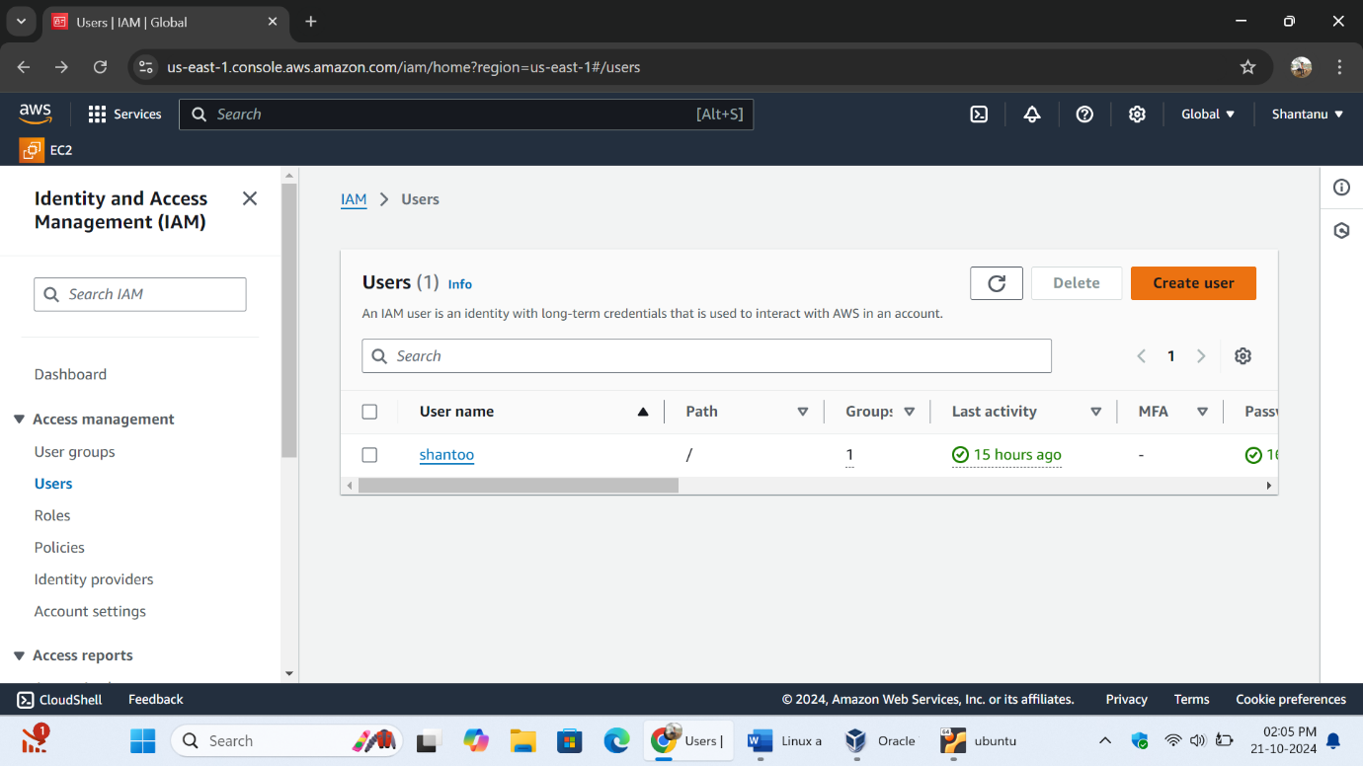

Step 2] Selecting the EC2 full access policy for the user by selecting the option of attach policies directly.

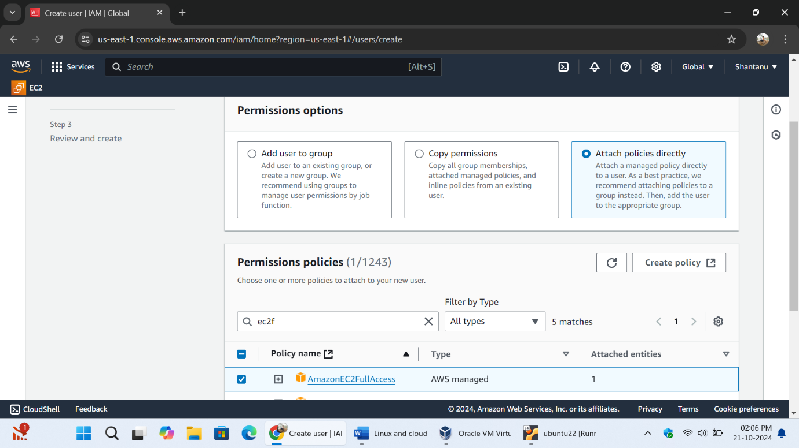

Checking the review of the IAM user is everything selected correctly or not.

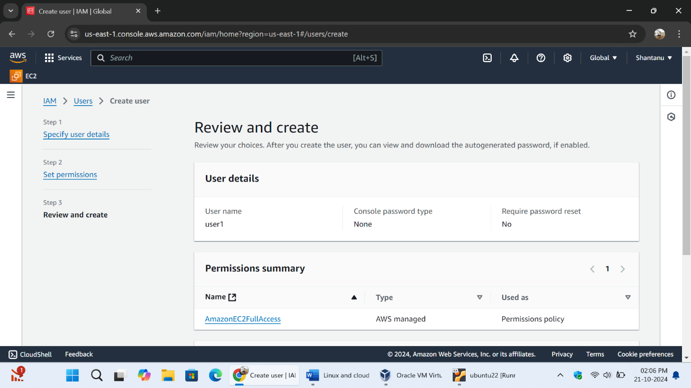

New IAM user has been successfully created having User name as “user1” with the full EC2 access permission.

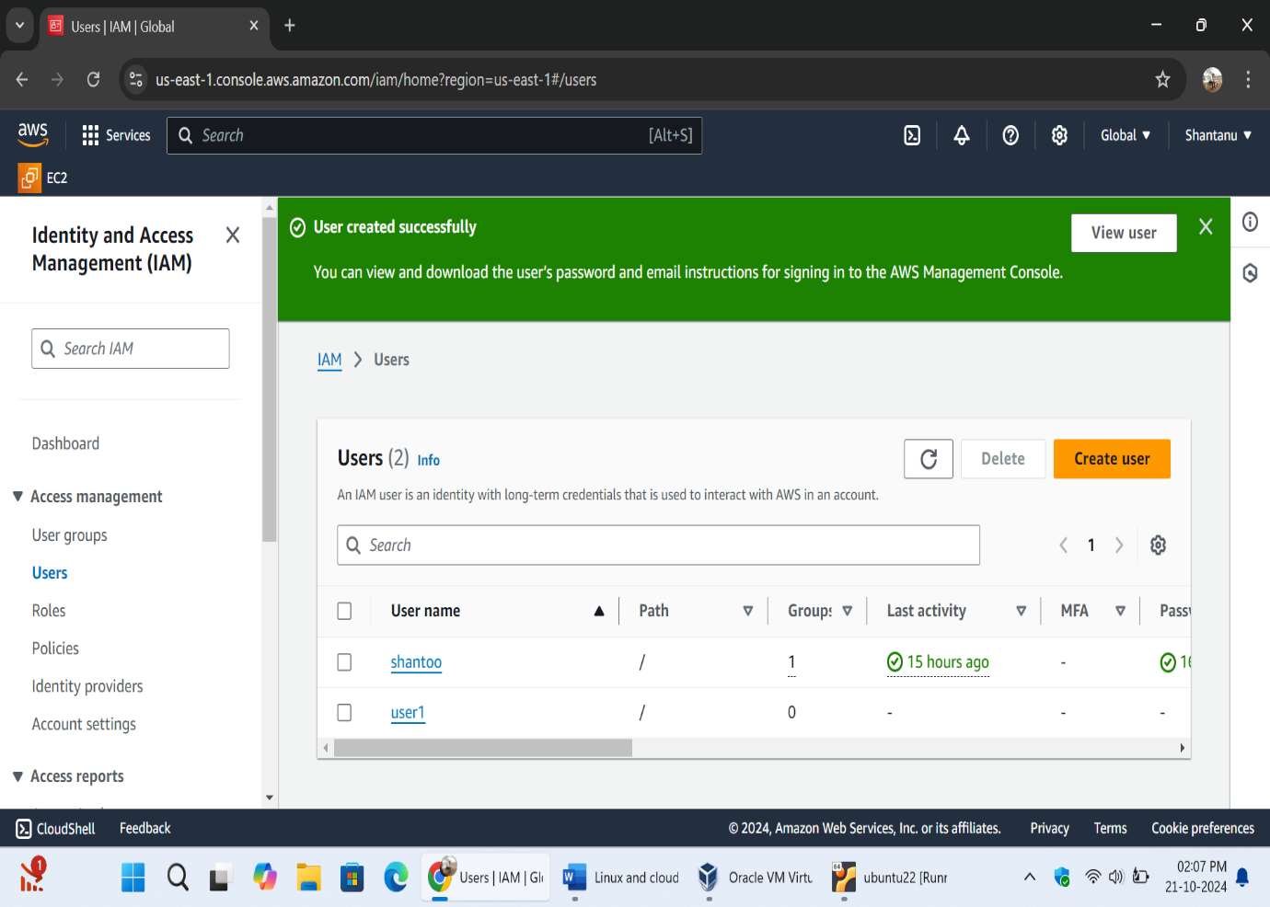

Step 3] Creating the Access key for the user1. Access key gives us an secrete access code file which further used in the login of user from CLI.

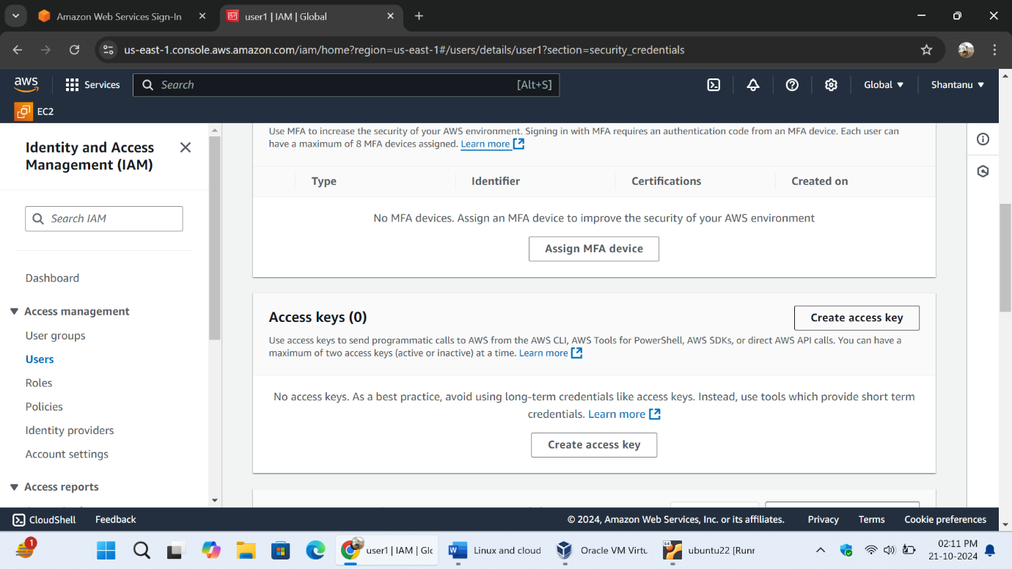

Selecting the command line interface i.e. CLI for download Access key

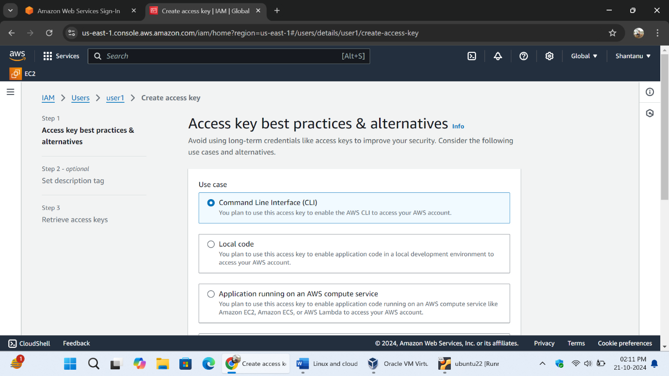

Access key has been successfully created and the credential of the access key has been downloaded in the .csv file format.

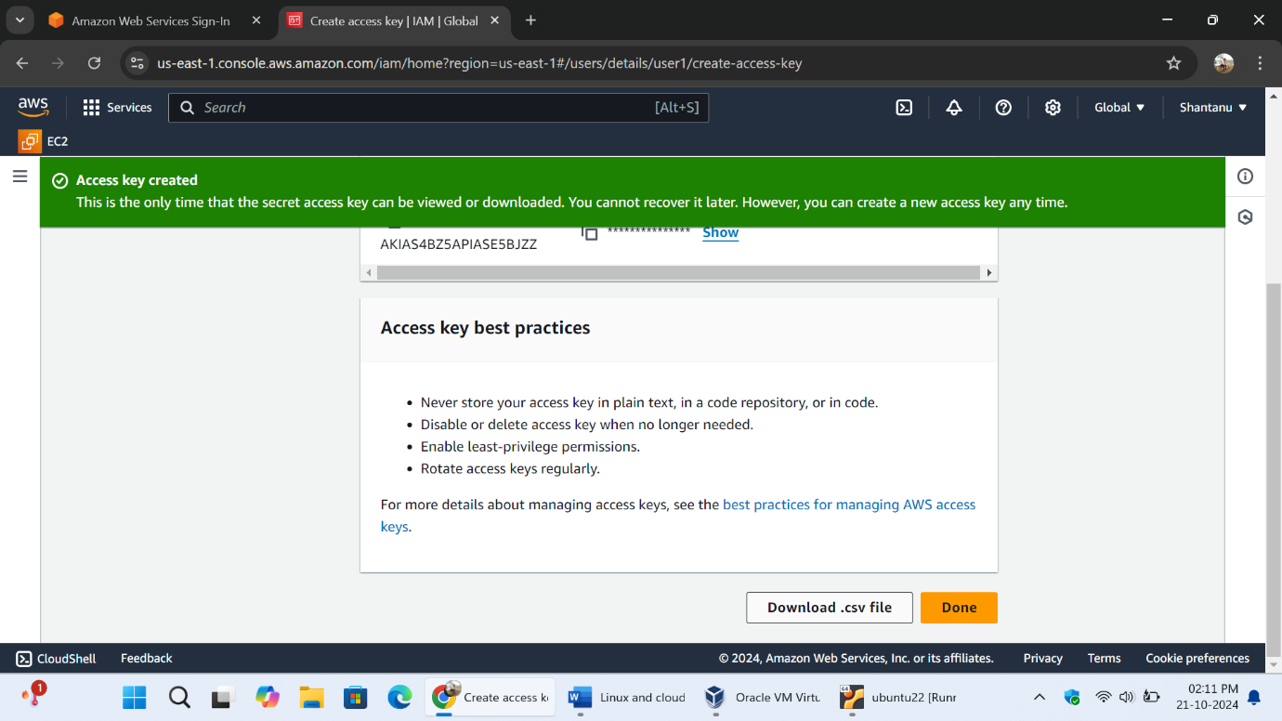

After that to enable the console access of the user1 click on the manage console access and click on generate password . after doing all the steps the console password has been generated successfully. Download there .csv file also

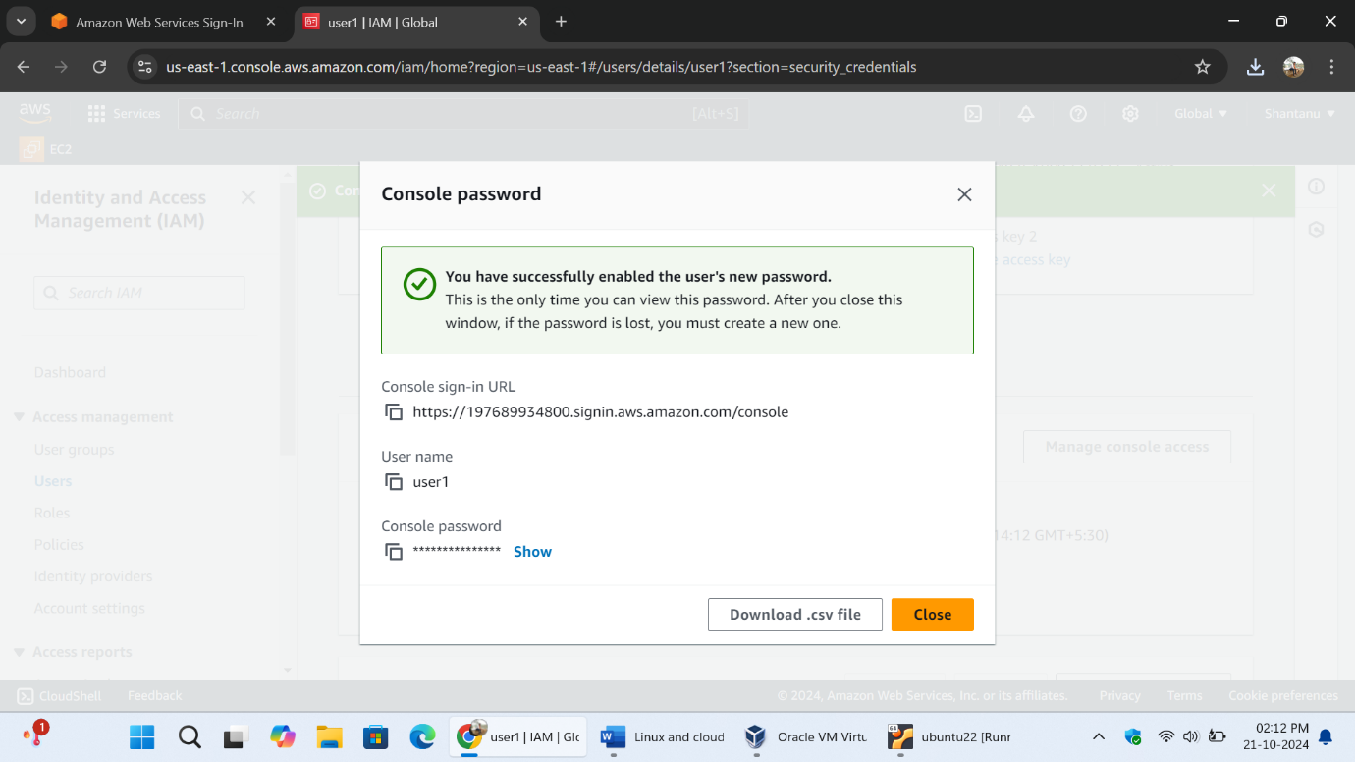

Step 4] login to the AWS with the help of the IAM user1 login credentials which we have created in the previous step.

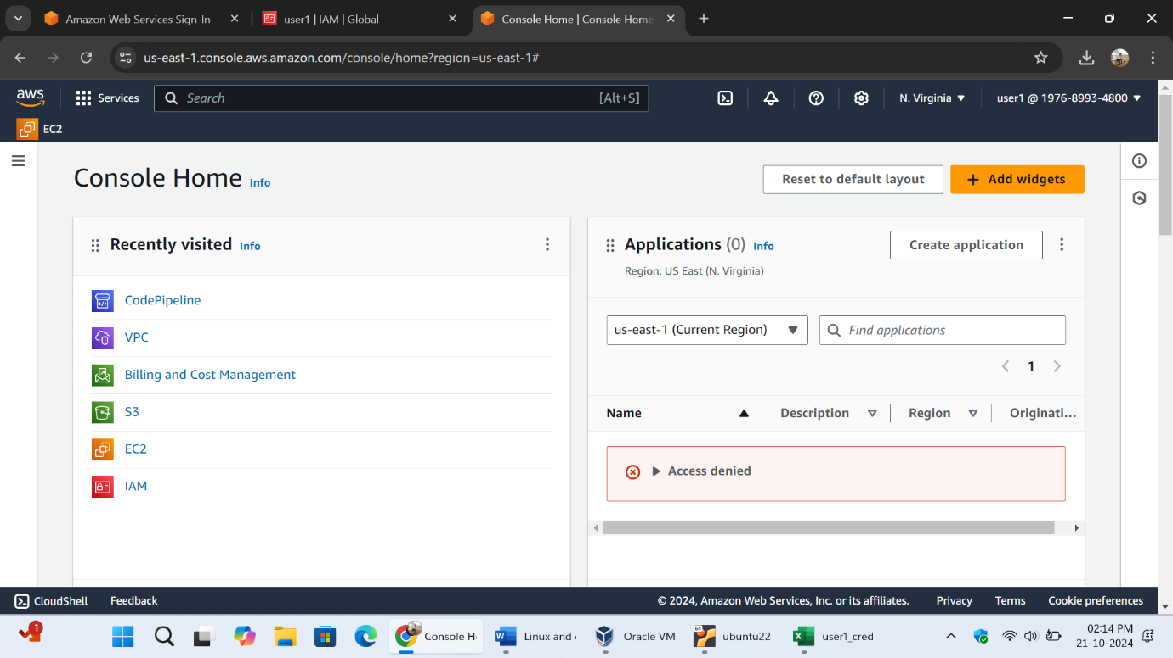

The all EC2 instances of the root user has displaying on the IAM user.

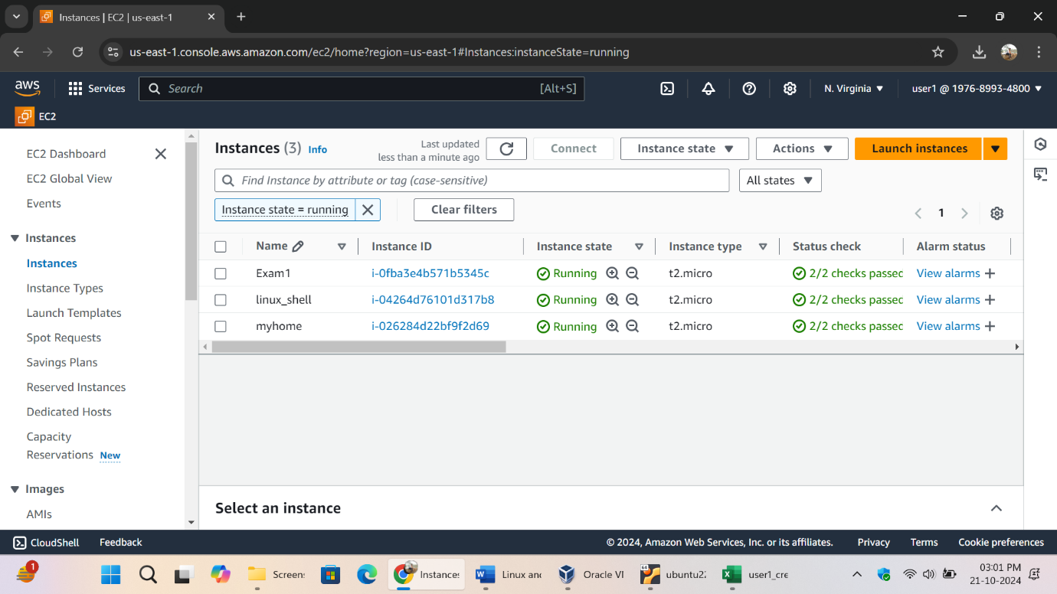the ec2 system has been successfully started and enabled with the user1.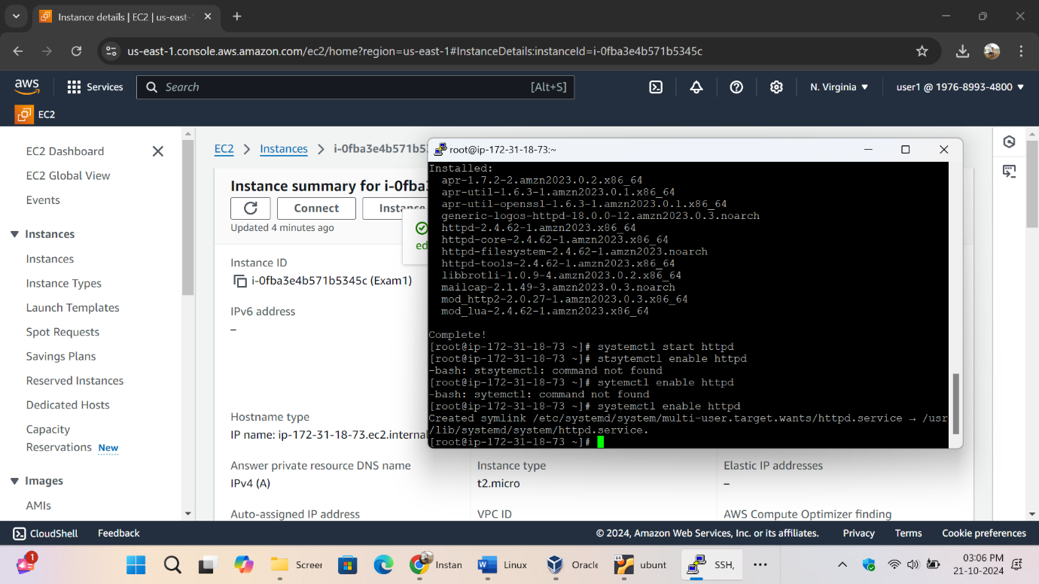

Step 5] Again login with the root user for creating the S3 bucket.

The root user logged in having username “Shantanu”. Search for the s3 bucket click on create bucket to create new bucket.

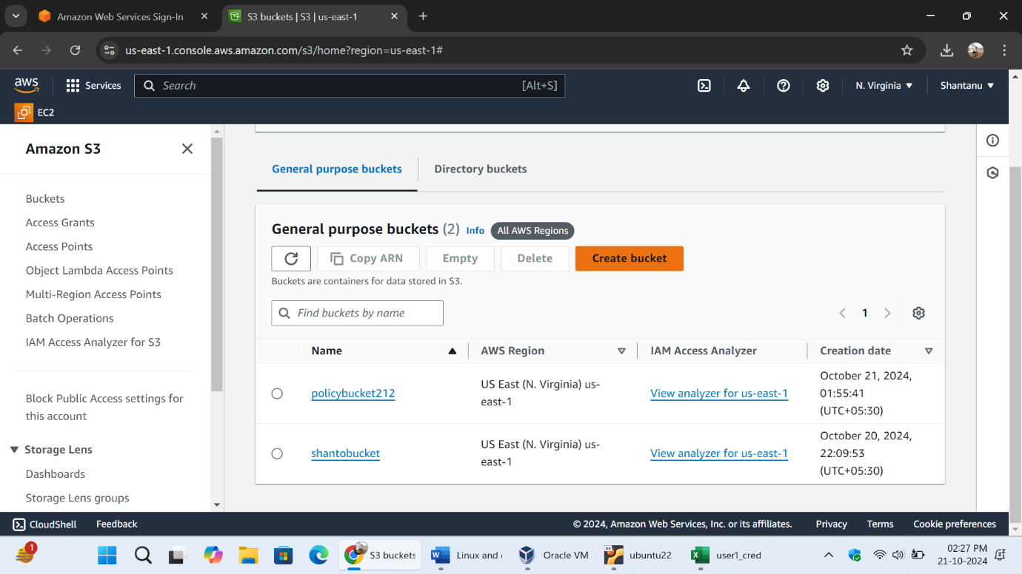

Step 6] S3 bucket has been created successfully . with an unique name “ exambucket-53”. 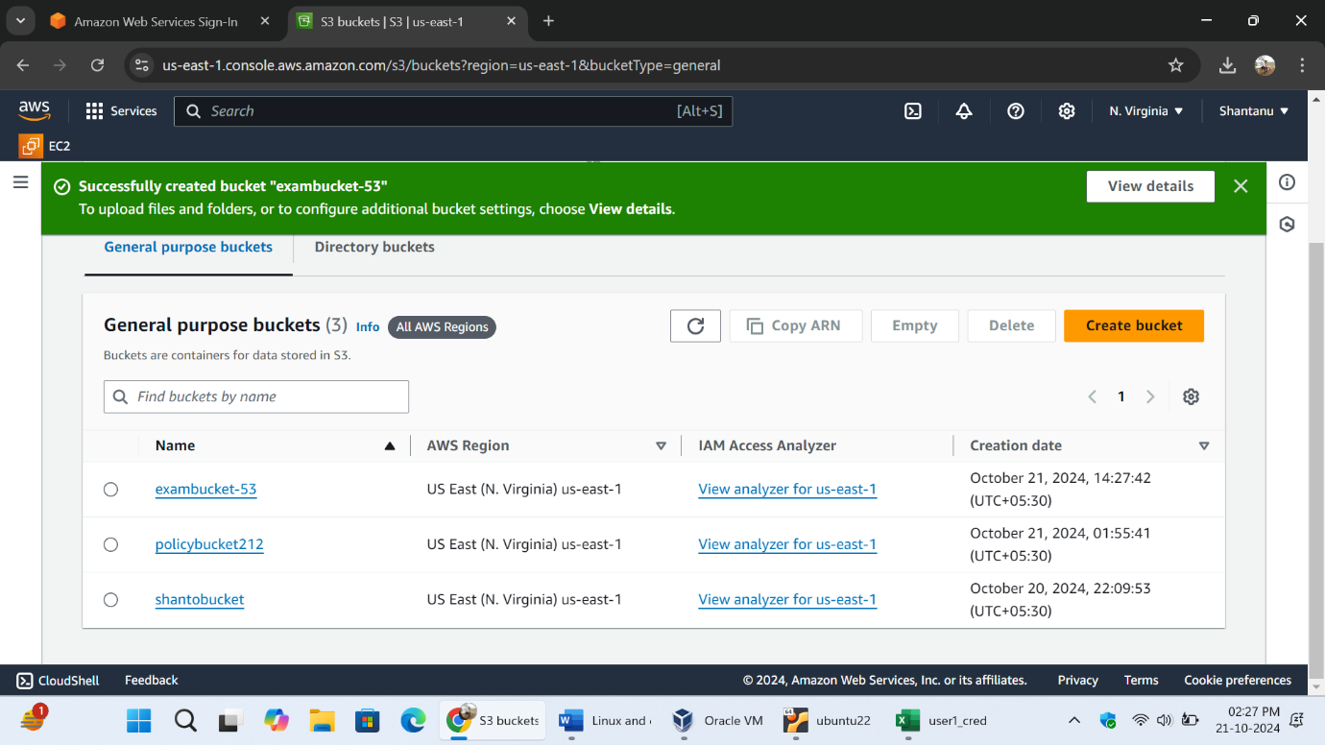

Step 7] Uploading the html file.

Click on bucket name and this interface has been open click on upload.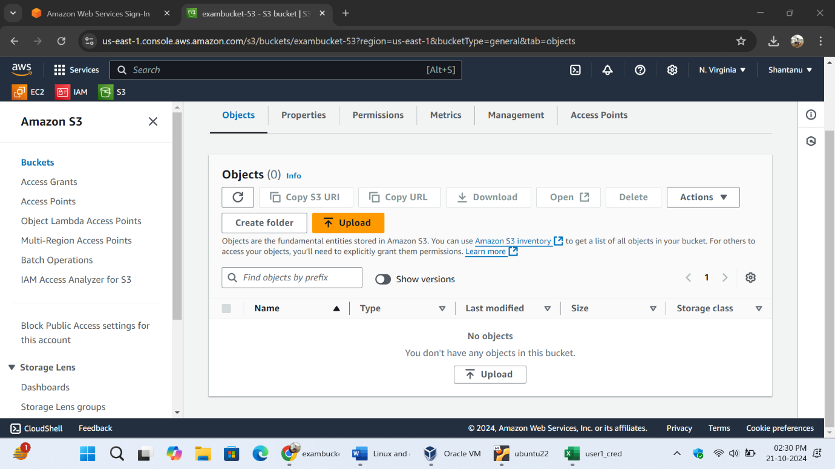

Creating the new html file having the content “Hello , welcome to my page” saving with .html extension

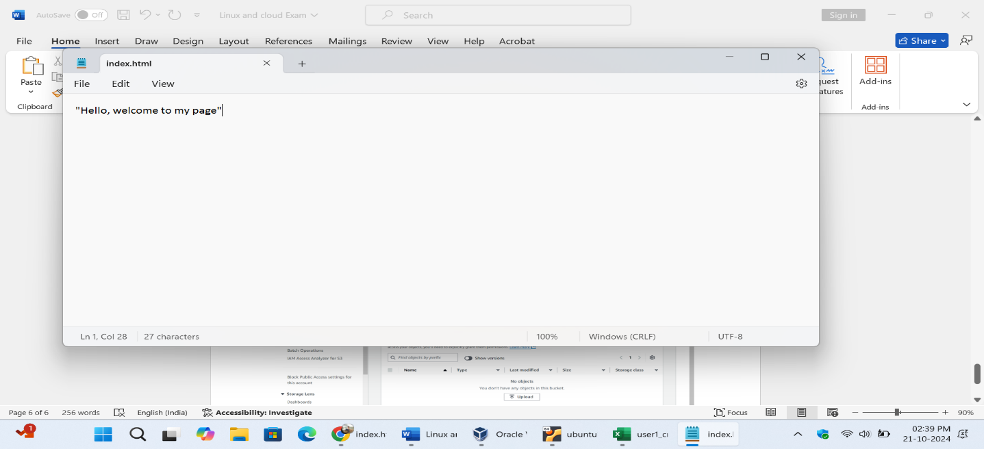

File has been uploaded successfully.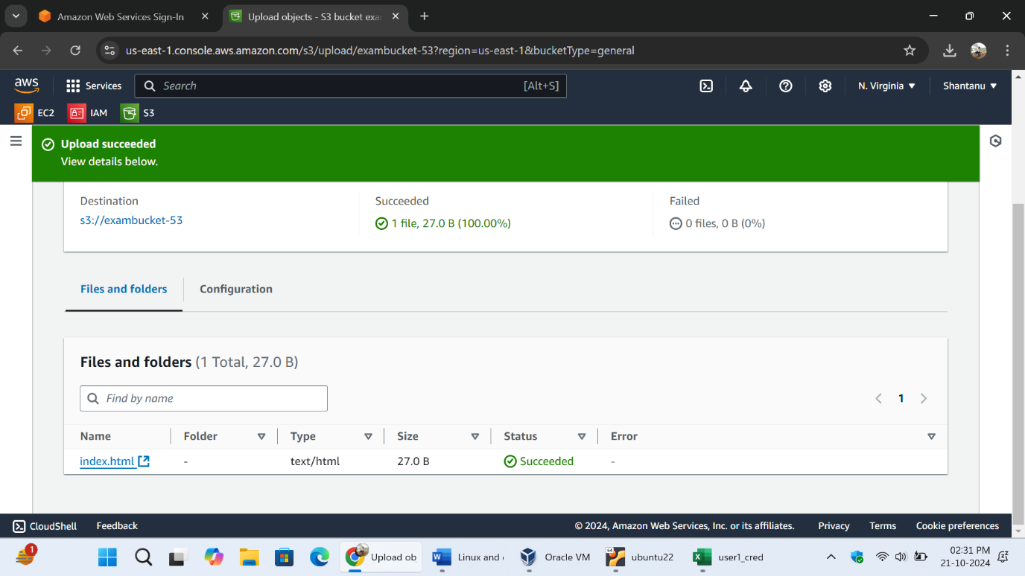

The bucket exambucket-53 contains the index.html file.

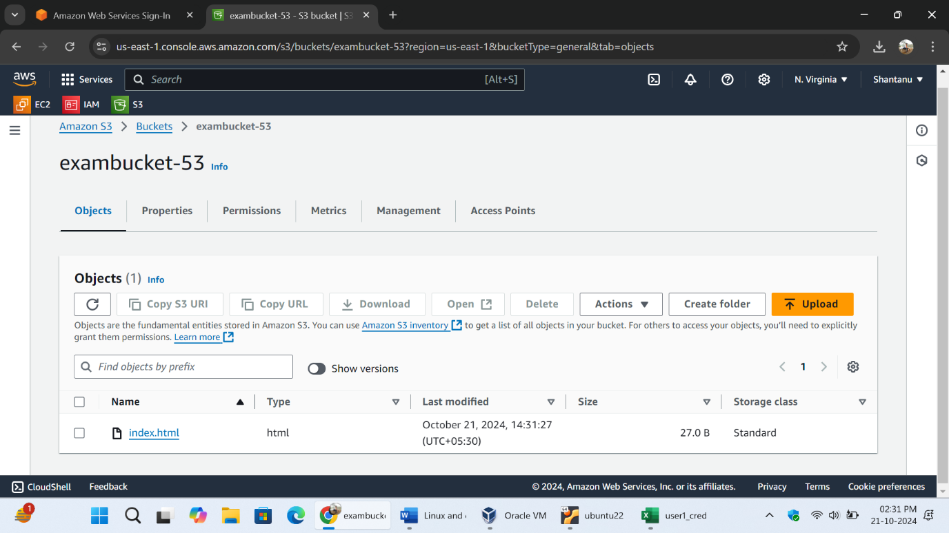

Step 8] enabling the static website hosting of bucket.

Click on bucket name . scroll down and find the Enable static website hosting and click on the enable radio button. 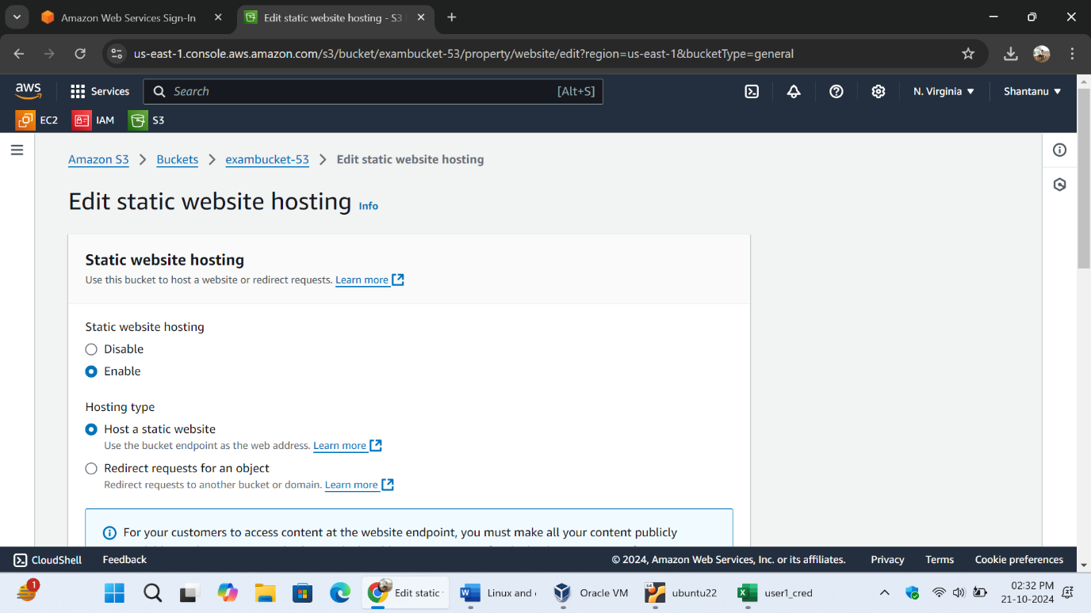

The bucket is successfully enabled with static website hosting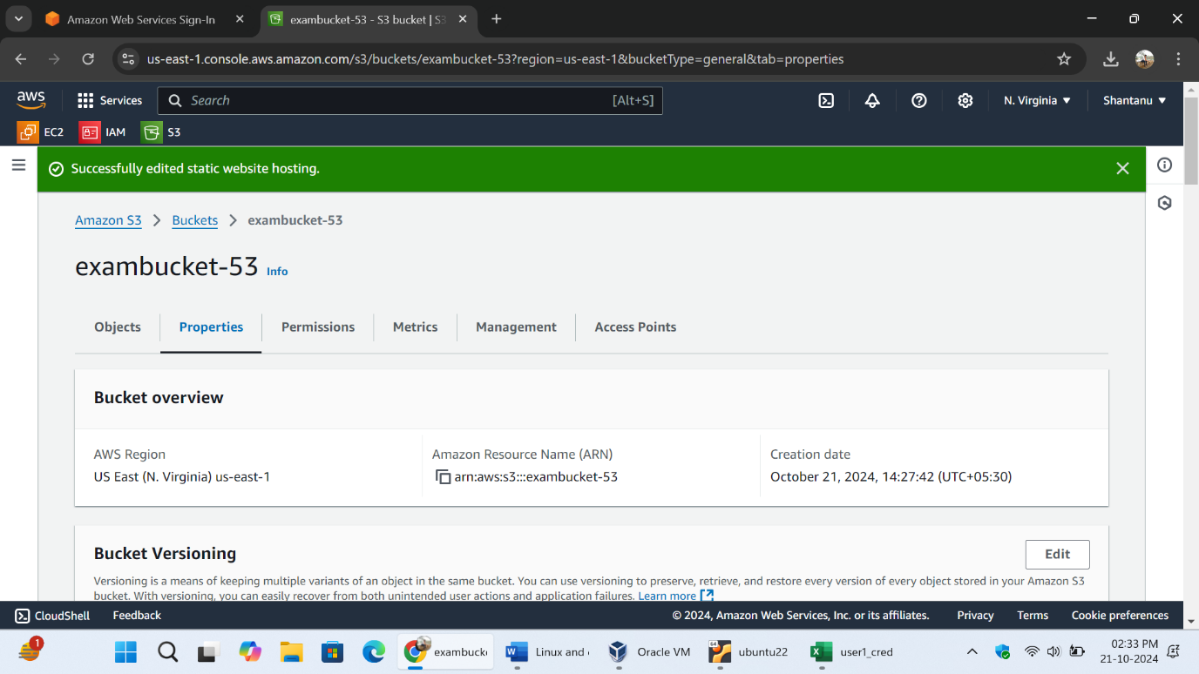step 9] making public access . click on action click on make public access .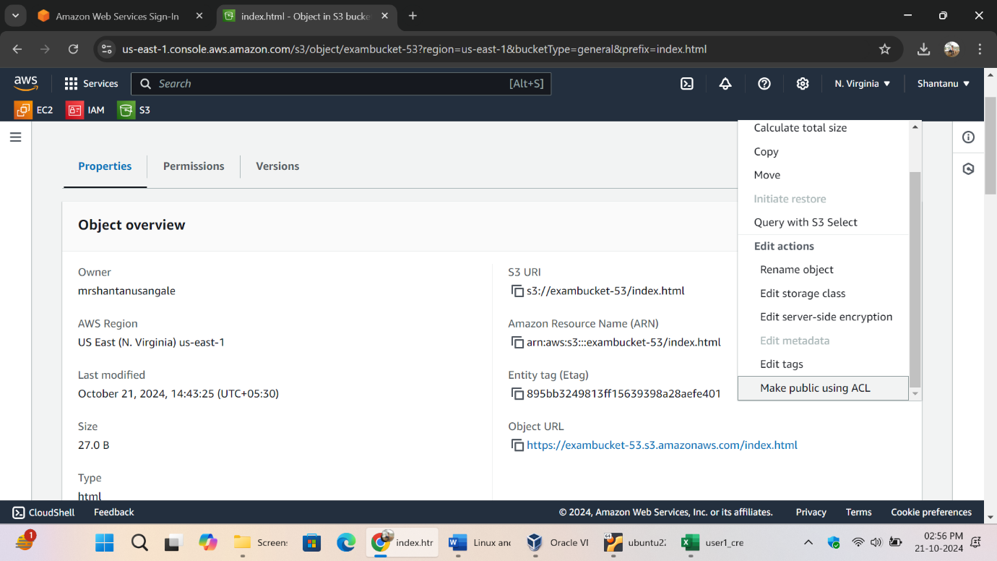

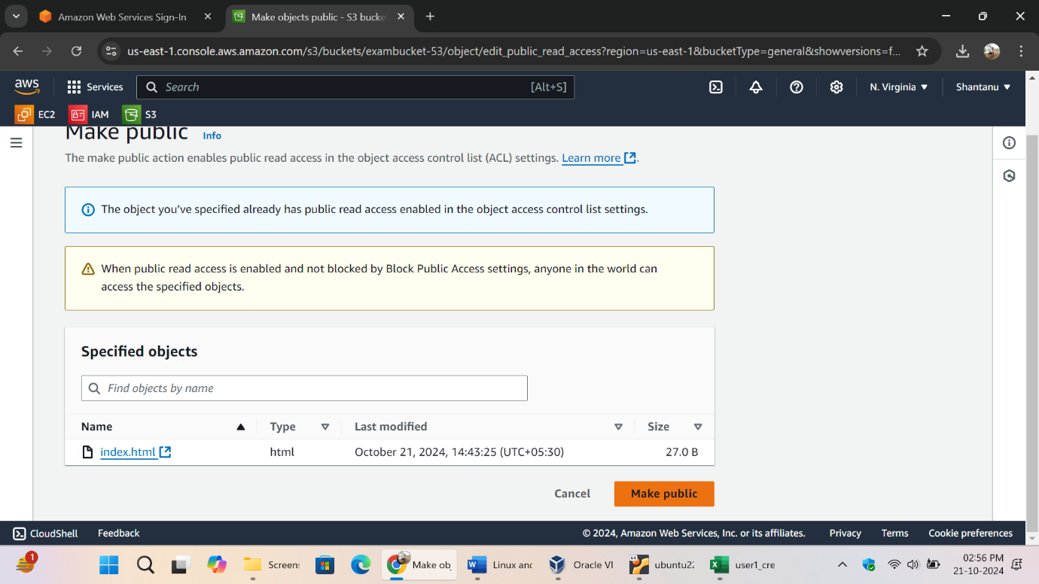The file is successfully public accessible.

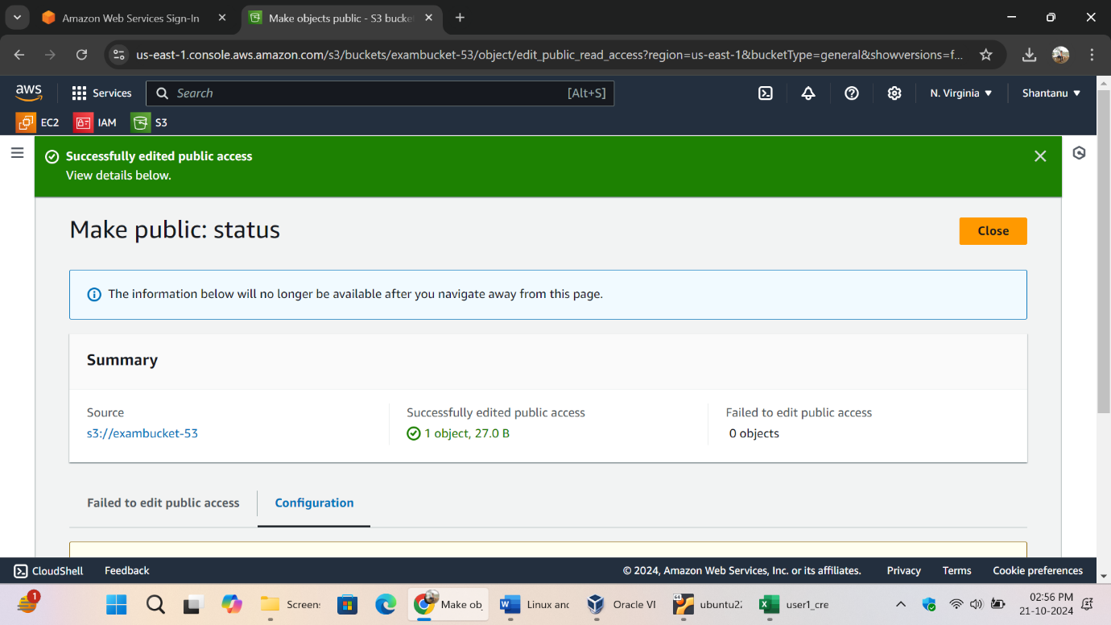step10] displaying the file with the help of the object url. Copied the index.html URL. 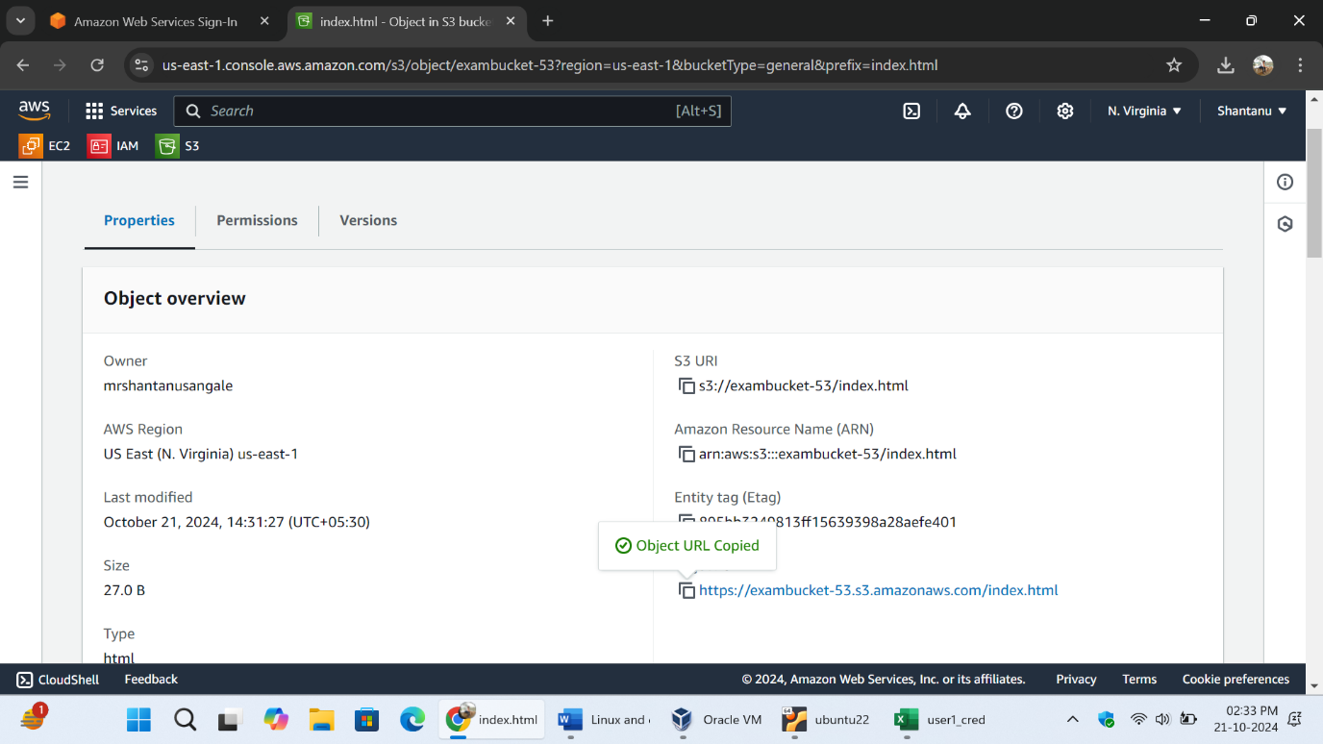pasted it on the browser and the content of the file has been displayed.

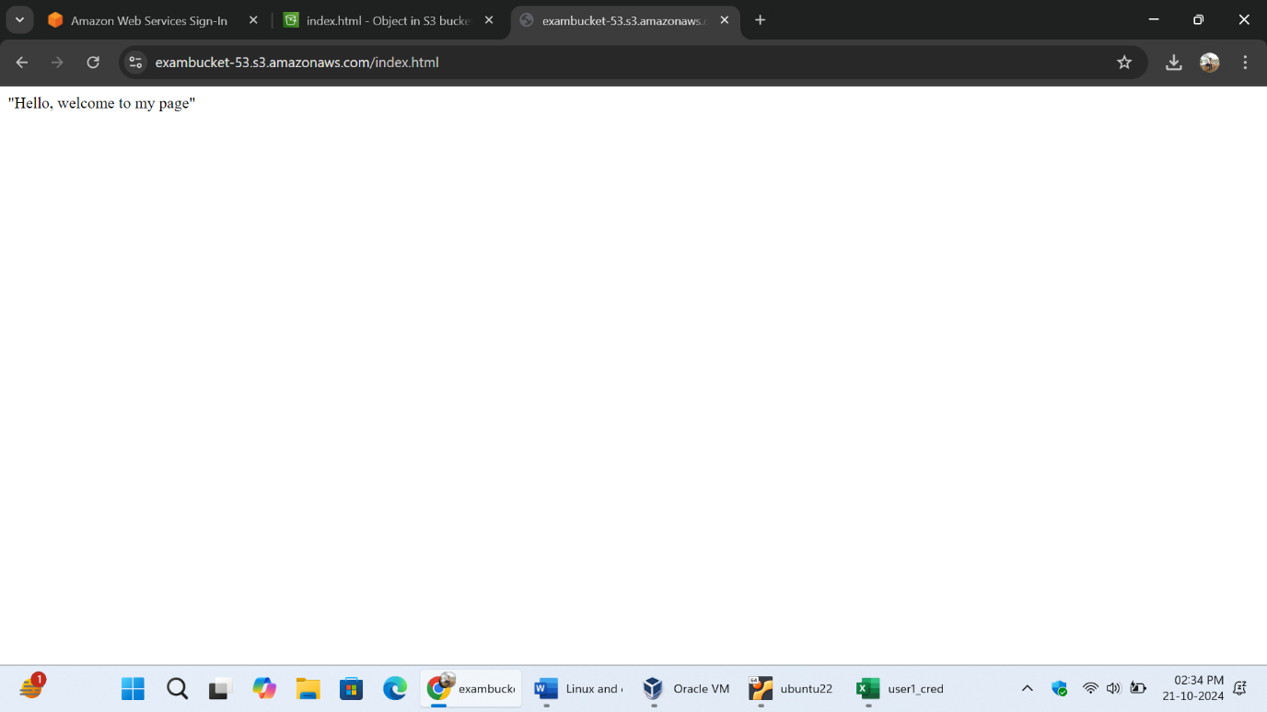

**Linux :-**

**Q.1] code =**

#!/bin/bash

echo "enter the first num"

read num1

echo "enter the second num"

read num2

echo "enter the third num"

read num3

echo "The three numbers are $num1, $num2, $num3"

if [ $num1-le $num2] && [ $num1 le $num3]; then

echo "$num1 is smaller"

elif [ $num2le $num3]; then

echo "$num2 is smaller"

else

echo "$num3 is smaller"

fi

avg=0

sum=$((num1+num2+num3))

avg=$((sum / 3))

echo "average is $avg"

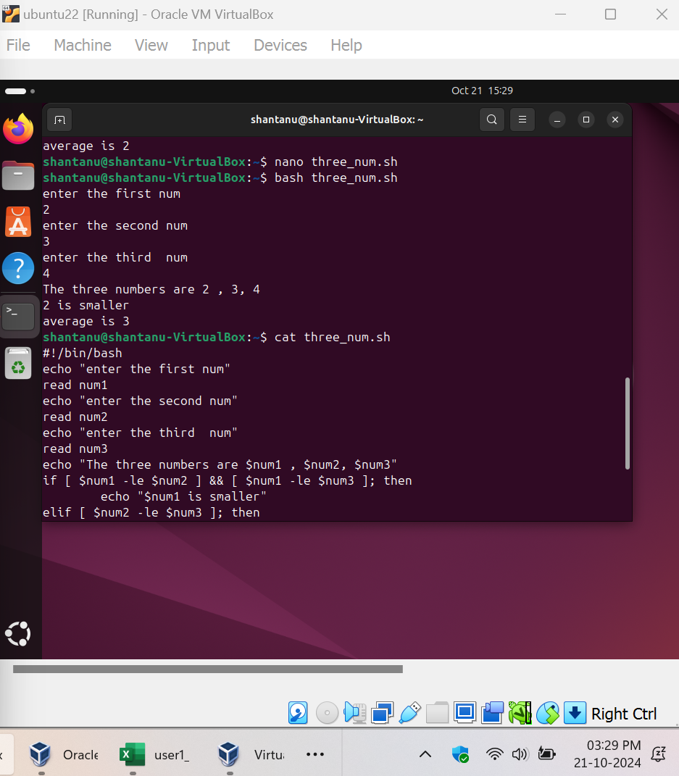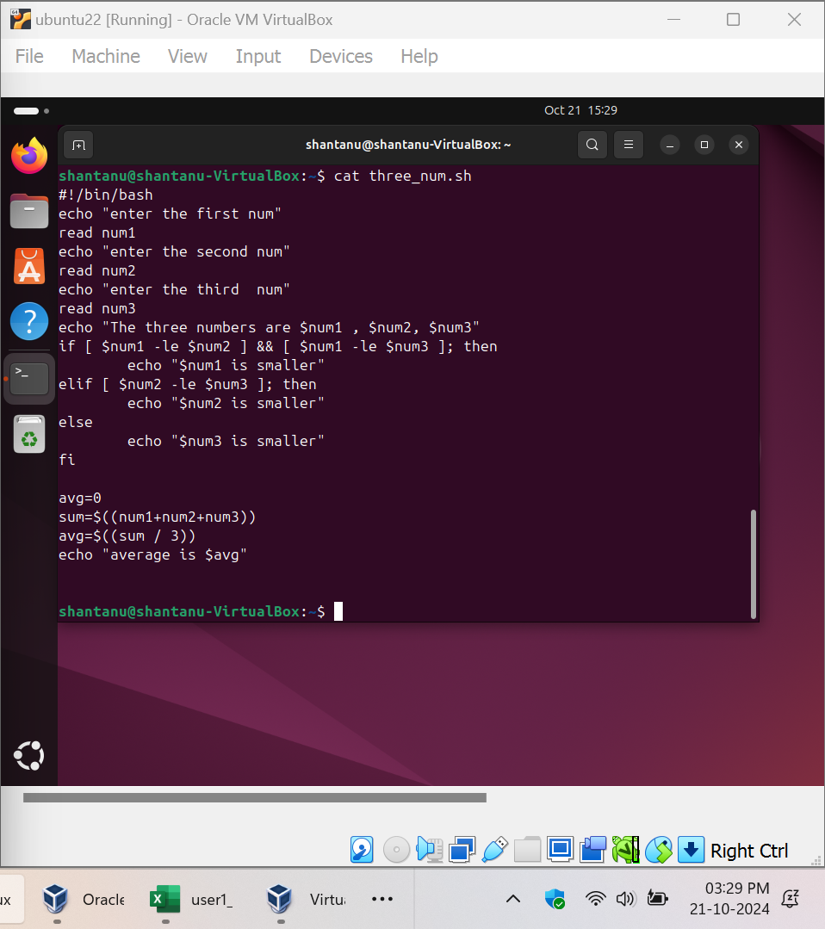

Q.2 –

Commands

